## horizontal line



Expense Tracker

16/08/2025

**─**

Abdullah Al Noman

NodeSeekers

Khilkhet, Dhaka, Bangladesh

# Overview

.

# Goals

1. Keep track of money spent.
2. Allow users to view expenses history.

# Features

1. Add an expense with amount & description.
2. Store the expense added.
3. View all expenses history with description and amount.
4. Show total expense.

## Tools

* Macbook Pro Mid-15
* Apache Netbeans
* Data we need - Arraylist

# Milestones

## When the program runs :

Show a menu -

1. Add expense
2. View expense
3. Show total expense
4. Exit

## User choose an option

## User perform the action

## Go back to menu until they choose *Exit*

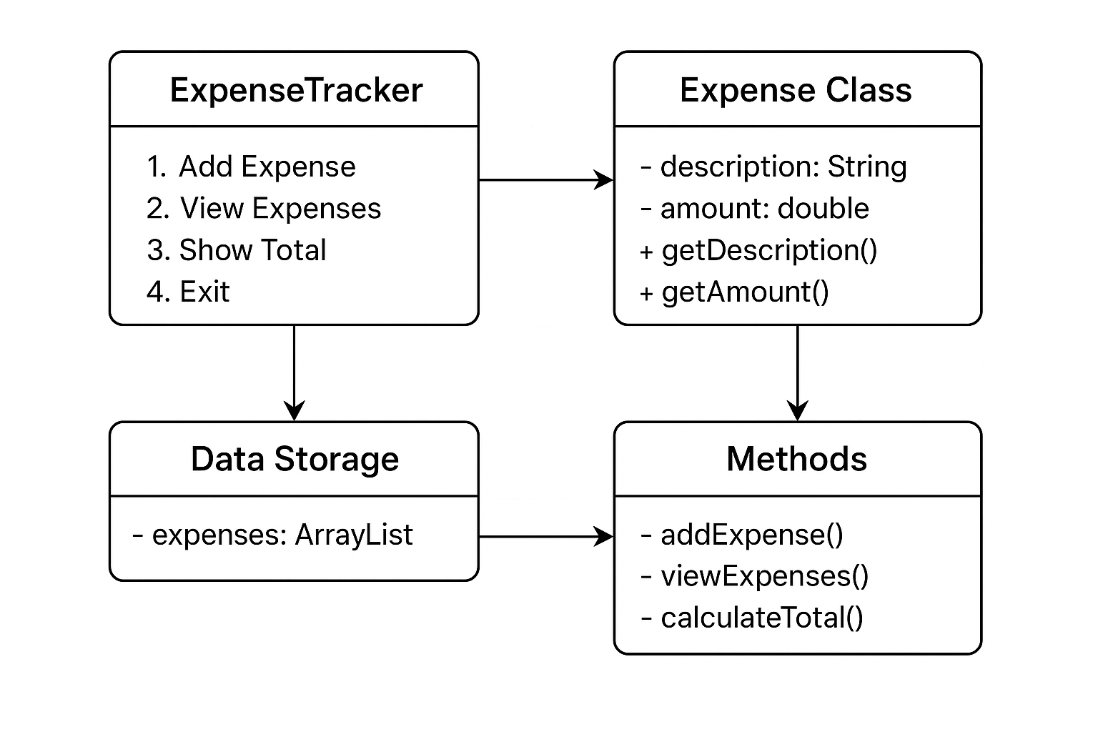

**- Block Diagram**